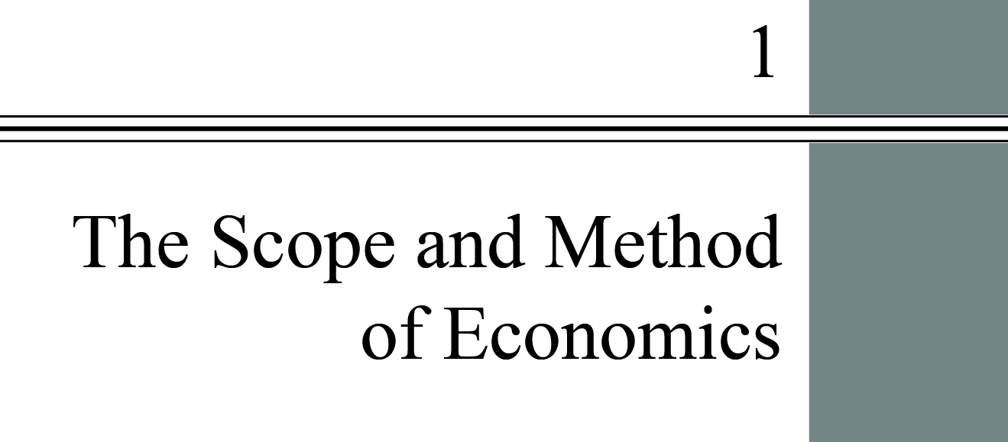

**Chapter Outline**

**Why Study Economics?**

Identify three key reasons to study economics. Think of an example from your life in which understanding opportunity costs or the principle of efficient markets could make a difference in your decision making.

**The Scope of Economics**

Describe microeconomics, macroeconomics, and the diverse fields of economics.

**The Method of Economics**

Think about an example of bad causal inference leading to erroneous decision making. Identify the four main goals of economic policy.

**Appendix: How to Read and Understand Graphs**

Understand how data can be graphically represented.

DETAILED Chapter Outline

I. Introduction

This chapter shows how economics relates to everyday lives. It discuss the interactions between the United States and other countries, while also comparing the United States to other countries. Along the way macroeconomics is introduced with the notions of employment, production, and GDP (although the authors don’t use that term). Foreign trade is also mentioned at the level of U.S. exports and imports. The section concludes with a definition of economics that emphasizes the two fundamental economic problems: scarcity and choice. *Economics* is the study of how individuals and societies choose to use the scarce resources that nature and previous generations have provided.

II. Why Study Economics

There are three main reasons to study economics:

A. To Learn a Way of Thinking. Also described as a way to make decisions, the economic way of thinking involves understanding three fundamental concepts

1. *Opportunity Cost* is the best alternative that we forgo, or give up, when we make a choice or a decision. Every decision means giving up something.

a. Economists are fond of trade-offs as a way of thinking about decision making. Taking one action usually means giving up something else. As the text states, “The full ‘cost’ of making a specific choice includes [the value of] what we give up by not making the best alternative choice.”

b. Opportunity costs arise because resources are scarce. Scarce means limited. Resources are scarce because human wants exceed what we can produce from our current resources.

2. Marginalism: *Marginalism* is the process of analyzing the additional or incremental costs or benefits arising from a choice or decision. Marginal means a small change. The text uses *marginal cost*, the cost of increasing production by one unit. This can be illustrated by putting added miles on a car; the change in the odometer reading is the marginal mileage.

3. Efficient Markets−No Free Lunch: An *efficient market* is a market in which profit opportunities are eliminated almost instantaneously. In efficient markets, profit opportunities are eliminated rapidly by the actions of those seeking the profits.

B. To Understand Society

1. Economic decisions shape the physical environment and influence the character of society. The text cites the examples of the Industrial Revolution of the late eighteenth and early nineteenth centuries and the e-revolution of the late 1990s. The *Industrial Revolution* was the period in England during the late eighteenth and early nineteenth centuries in which new manufacturing technologies and improved transportation gave rise to the modern factory system and a massive movement of the population from the countryside to the cities.

2. The chapter points to the market-driven miracle of millions of workers, each pursuing his or her own self-interest, producing output efficiently while also earning a living. These decisions have an enormous influence on the direction in which societies evolve. The text’s example of the shrinking agricultural labor force is even more extreme today. At the same time, employment in technology-related industries has been booming. The text mentions internet companies. Biotech firms are also important. In each case, the main thrust of the change has been the desire of entrepreneurs to build new businesses and earn a profit.

C. To Be an Informed Citizen: Many political issues citizens vote for deal with economic issues. The chapter mentions government payments for public schools and roads, the Obama health care plan, and ticket scalping as three examples. Without a basic understanding of economics, citizens are likely to vote for policies that are not in their best interests.

III. The Scope of Economics

A. Microeconomics versus Macroeconomics

1. *Microeconomics* is the branch of economics that examines the functioning of individual industries and the behavior of individual decision-making units—that is, firms and households.

2. *Macroeconomics* is the branch of economics that examines the economic behavior of aggregates—income, employment, output, and so on—on a national scale.

B. The Diverse Fields of Economics: Table 1.2 on page 7 of the text lists some fields of specialty in economics (analogous to specialties in medicine).

**Web Resources**

Most fields of economic research have at least one web site. The American Association of Wine Economists is at <http://www.wine-economics.org/>. The *Journal of Sports Economics* (<http://jse.sagepub.com/>) is published in association with the North American Association of Sports Economists (<http://www.byuresearch.org/naasportseconomists/>).

IV. The Method of Economics

A. Positive and Normative Economics

1. *Positive economics* is an approach to economics that seeks to understand behavior and the operation of systems without making judgments. It describes what exists and how it works.
2. *Normative economics* is an approach to economics that analyzes outcomes of economic behavior, evaluates them as good or bad, and may prescribe courses of action. Also called *policy economics*. When economists disagree, the points they argue about are often normative points (differences of opinion and values).

B. Theories and Models:

1. A *model* is a formal statement of a theory, usually a mathematical statement of a presumed relationship between two or more variables.

2. A *variable*: a measure that can change from time to time or from observation to observation.

3. *Ockham’s Razor* is the principle that irrelevant detail should be cut away. Of course, be sure it’s irrelevant! Formally, Ockham’s Razor says that when there are two equally good explanations of a phenomenon, the simpler of the two should be used.

4. *All Else Equal*: *Ceteris Paribus* is a device used to analyze the relationship between two variables while the values of other variables are held unchanged. (*Ceteris paribus* is often abbreviated *cet. par.*)

5. Expressing Models in Words, Graphs, Equations: Economists use graphs and mathematics to make it more difficult to overlook some effects. One obvious example is income and substitution effects in consumer theory.

6. Cautions and Pitfalls: *What Is Really Causal?*

a. Just because event A happened before event B does not mean A caused B. Examples of this sort of thinking are everywhere. Confusing correlation with causation has become a cottage industry for much of the media.

b. *Post hoc, ergo propter hoc* means literally “after this (in time), therefore because of this.” A common error made in thinking about causation: If Event A happens before Event B, it is not necessarily true that A caused B. The *post hoc fallacy* is the incorrect belief that because event B occurs after event A then A caused B. This is closely related to correlation and causation. *Correlation* refers to things happening together. Just because two variables move closely together doesn’t mean one *causes* the other.

c. Testing Theories and Models: *Empirical economics* is the collection and use of data to test economic theories. Researchers look at data collected over time and across different categories or conditions (e.g., age groups, locations) and try to draw conclusions. Controlled experiments are difficult in economics (and other social sciences), but are not impossible.

**Web Resources**

Go to a Web site for data about the economy. The text mentions the Bureau of Labor Statistics, for example. Other good sources are the Bureau of the Census, the Federal Reserve, the Bureau of Economic Analysis, and (more exotically) the CIA’s World Factbook available at   
<https://www.cia.gov/library/publications/the-world-factbook/index.html>.

C. Economic Policy: Without objectives it’s impossible to come up with policies. Economists have looked at four different criteria for judging outcomes: efficiency, equity, growth, and stability. Using these criteria to evaluate a policy often leads to conflicting recommendations. This is especially true for the first two (efficiency and equity).

1. *Efficiency* is the condition in which the economy is producing what people want at the least possible cost. As the text notes, this is allocative efficiency.

2. *Equity* means fairness. This is impossible to define universally. An allocation that seems fair to one person will be viewed by another as highly skewed.

3. *Economic growth* is an increase in total output of an economy. Growth occurs when a society acquires new resources or when it learns to produce more using existing resources.

a.Economists often define growth as an increase in output per capita.

b. Government policies can encourage or discourage growth.

4. *Stability* is a condition in which national output is growing steadily, with low inflation and full employment of resources. The causes of instability and the various techniques governments have used to try to improve stability are the core of macroeconomics.

**Web Resources**

Economic data is widely available on the web. I always try to download the data in spreadsheet format. For U.S. data students should visit <http://www.bea.gov>, <http://www.bls.gov>, and <http://www.census.gov>. Global data is available from <http://www.oecd.org>, <http://www.worldbank.org/>, <http://www.imf.org/>, and <http://www.un.org/en/databases/#stats>. Real statistics aficionados will want to try their hand at Eurostat (<http://epp.eurostat.ec.europa.eu/>). U.S. monetary statistics are at <http://www.federalreserve.gov> while Eurozone statistics are at <http://www.ecb.eu>.

Appendix: How to Read and Understand Graphs